
Story

Date | 25 October 2026
Team ID | Individual
Project Name | EV Market Analysis
Maximum Marks | 5 Marks

By using stories in Tableau, you can effectively communicate complex data in a way that is both interactive and engaging, making it easier for the audience to follow along and understand the insights. It’s a tool for data storytelling, allowing you to present insights in a cohesive, engaging way that takes viewers through a logical progression of findings or analyses.
In Tableau, Story is a feature that allows you to create a sequence of dashboards, visualizations, and text to present data insights in a cohesive and narrative-driven way. It's like a slideshow within Tableau that guides the audience through a series of data points, helping them understand key insights, trends, or outcomes of your analysis.

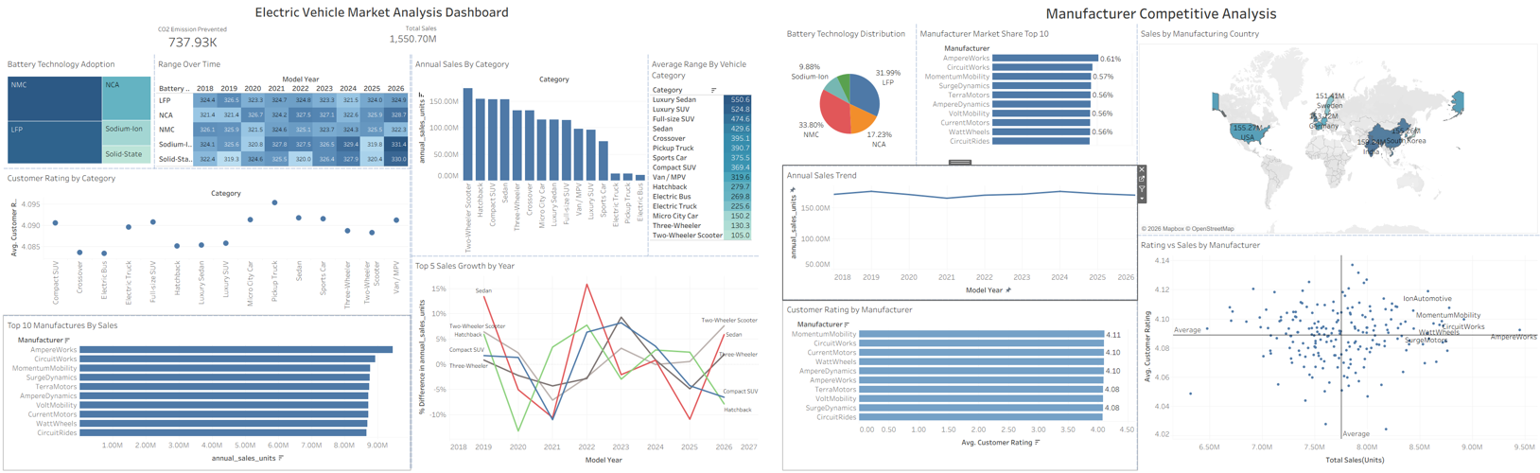

Observations:
- Two-Wheeler Scooter Leads Category Sales: Two-Wheeler Scooter, Hatchback, Compact SUV and Sedan generate the highest annual sales, while Electric Bus, Pickup Truck and Electric Truck are the smallest categories.
- Battery Technology Split: NMC (33.80%) and LFP (31.99%) together account for about two thirds of the market, with NCA at 17.23% and Sodium-Ion at 9.88%.
- Luxury Vehicles Offer the Longest Range: Luxury Sedan (550.6) and Luxury SUV (524.8) have the highest average range, while Two-Wheeler Scooter has the lowest at 105.0.
- Competitive and Balanced Manufacturer Market: AmpereWorks leads in sales and market share at 0.61%, but the top 10 manufacturers are all within a narrow share range of about 0.56% to 0.61%.

Activity 2:
Publish Story on Tableau Public and Paste Public link below
https://public.tableau.com/app/profile/hussain.saifee5441/viz/EVMarketAnalysis_17930983632520/ElectricVehicleMarketAnalysisDashboard?publish=yes&showOnboarding=true

